Advancing Diagnostic Precision and Treatment Selection in MG
Live Webinar
June 8, 2026

Activity Overview
The MDA Grand Rounds: Advancing Diagnostic Precision and Treatment Selection in MG is a 90-minute live webinar in which expert faculty share up-to-date knowledge, clinical experience, and institutional practices related to MG diagnosis and management. The session highlights best practices for distinguishing MG from mimicking conditions, interpreting antibody and electrophysiologic findings, and selecting appropriate therapies across MG phenotypes.
The 90-minute live webinar will feature a multidisciplinary panel (eg, neurologist, pharmacist, ophthalmologist, other MG experts) who will review current understanding of MG subtypes (AChR+, MuSK+, LRP4+, seronegative) and their implications for diagnostic evaluation and therapy selection.
Panelists will discuss multidisciplinary strategies for managing fluctuating weakness, bulbar and respiratory involvement, comorbid autoimmune diseases, and quality-of-life considerations. Institutional practices will be compared to illustrate variations in care models, and a moderated Q&A will enable participants to engage directly with experts. The session will be recorded and made available for on-demand viewing.

Target Audience
This activity is designed for an audience of neurologists (including fellows and residents), and advanced practice providers, pharmacists, social workers who participate in MG diagnosis and management.

Learning Objectives
Upon completion of the educational activity, participants should be able to:

- Identify appropriate diagnostic and electrophysiologic testing strategies to distinguish MG from conditions with similar presentations.
- Characterize MG patient profiles based on antibody status, clinical features, and test findings.
- Describe available and emerging MG therapies and their MOAs to support treatment selection.

Criteria for Success
There is no fee to participate in this activity. A certificate of completion will be awarded based on the participant's attendance and completion of the online evaluation/claim credit form.

https://akhcme.com/content/advancing-diagnostic-precision-and-treatment-selection-mg

- Click Start course.
- Complete the evaluation and click Submit.
- Your certificate will be available immediately for download.

Please claim your credit by 7/8/2026

If you have questions about this CE activity, please contact AKH Inc at wendi@akhcme.com.

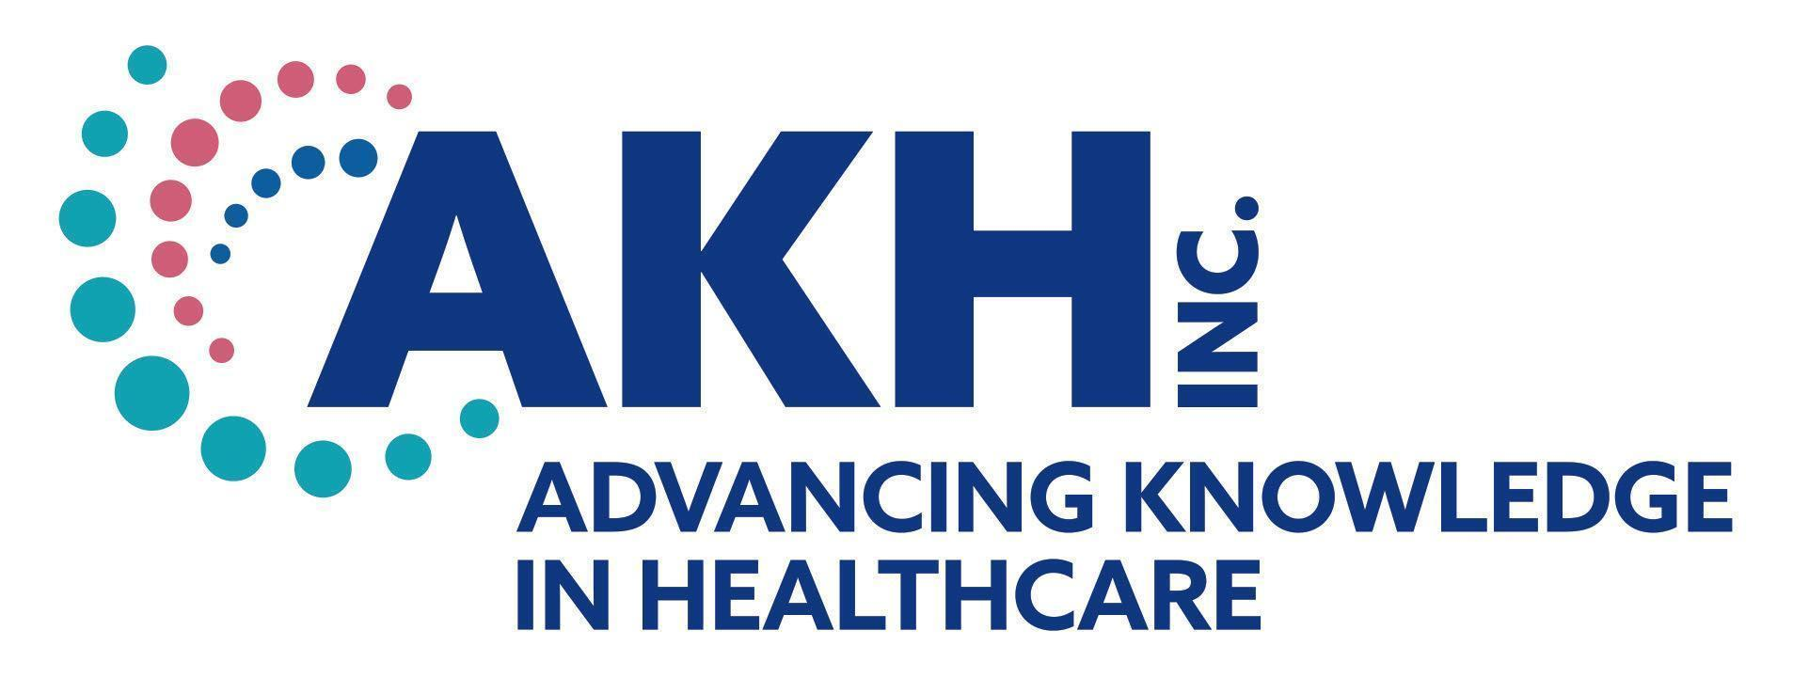
CE credit provided by AKH Inc., Advancing Knowledge in Healthcare.


In support of improving patient care, this activity has been planned and implemented by AKH Inc., Advancing Knowledge in Healthcare and MDA. AKH Inc., Advancing Knowledge in Healthcare is jointly accredited by the Accreditation Council for Continuing Medical Education (ACCME), the Accreditation Council for Pharmacy Education (ACPE), and the American Nurses Credentialing Center (ANCC), to provide continuing education for the healthcare team.

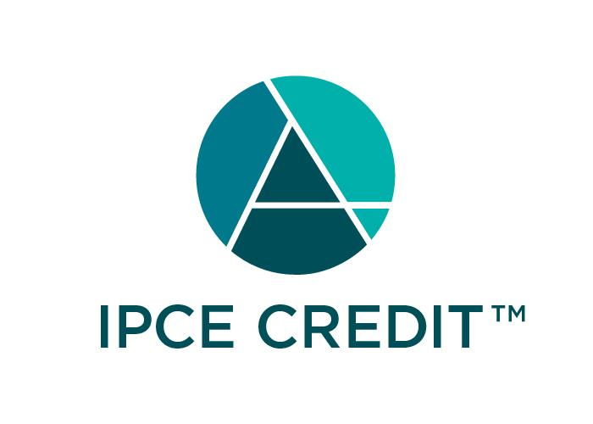This activity was planned by and for the healthcare team, and learners will receive 1.5 Interprofessional Continuing Education (IPCE) credit for learning and change.

Physicians
AKH Inc., Advancing Knowledge in Healthcare designates this live activity for a maximum of 1.5 AMA PRA Category 1 Credit(s)™. Physicians should claim only the credit commensurate with the extent of their participation in the activity.

Nurses
Credit being awarded: 1.5 ANCC contact hours

Physician Associate
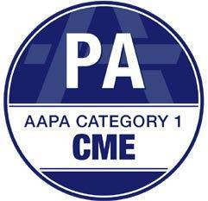
AKH Inc., Advancing Knowledge in Healthcare has been authorized by the American Academy of Physician Associates (AAPA) to award AAPA Category 1 CME credit for activities planned in accordance with AAPA CME Criteria. This activity is designated for 1.5 AAPA Category 1 CME credits. PAs should only claim credit commensurate with the extent of their participation.

Nurse Practitioners

This activity has been planned and implemented in accordance with the Accreditation Standards of the American Association of Nurse Practitioners (AANP) through the joint providership of AKH Inc., Advancing Knowledge in Healthcare and MDA. AKH Inc., Advancing Knowledge in Healthcare is accredited by the American Association of Nurse Practitioners as an approved provider of nurse practitioner continuing education. Provider number: 030803. This activity is approved for 1.5 contact hour(s) (which includes 0 hour(s) of pharmacology).

Social Workers
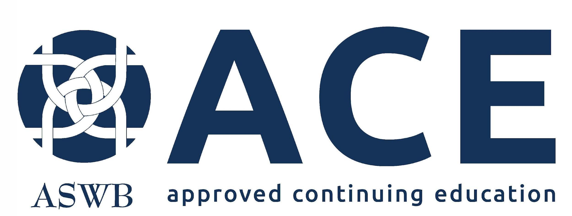
As a Jointly Accredited Organization, AKH Inc., Advancing Knowledge in Healthcare is approved to offer social work continuing education by the Association of Social Work Boards (ASWB) Approved Continuing Education (ACE) program. Organizations, not individual courses, are approved under this program. State and provincial regulatory boards have the final authority to determine whether an individual course may be accepted for continuing education credit. AKH Inc. Advancing Knowledge in Healthcare maintains responsibility for this course. Social workers completing this course receive 1.5 social work clinical practice continuing education credits.

Commercial Support
This activity is supported from an independent medical education grant from argenx US Inc., Johnson & Johnson, and UCB.

Disclosures
It is the policy of AKH Inc. to ensure independence, balance, objectivity, scientific rigor, and integrity in all of its continuing education activities. The author must disclose to the participants any significant relationships with ineligible companies whose products or devices may be mentioned in the activity or with the commercial supporter of this continuing education activity. Identified conflicts of interest are mitigated by AKH prior to accreditation of the activity. AKH planners and reviewers have no relevant financial relationships to disclose.

Disclosure of Unlabeled Use and Investigational Product
This educational activity may include discussion of uses of agents that are investigational and/or unapproved by the FDA. Please refer to the official prescribing information for each product for discussion of approved indications, contraindications, and warnings.

Disclaimer
This course is designed solely to provide the healthcare professional with information to assist in his/her practice and professional development and is not to be considered a diagnostic tool to replace professional advice or treatment. The course serves as a general guide to the healthcare professional, and therefore, cannot be considered as giving legal, nursing, medical, or other professional advice in specific cases. AKH Inc. specifically disclaim responsibility for any adverse consequences resulting directly or indirectly from information in the course, for undetected error, or through participants misunderstanding of the content. If you would like to opt out from future communications from AKH please send an email to optout@akhcme.com with your information with "Opt Out" in the subject line.

