Safe by Design: Filler Essentials
Live Webinar
08-03-2026

Activity Overview
Hyaluronic acid (HA) filler use continues to rise across aesthetic practice, and with it, the incidence of vascular adverse events (VAEs) — including vascular occlusion, skin necrosis, and vision loss — remains a critical patient safety concern. Many injectors, including experienced practitioners, lack structured training in facial vascular anatomy, region-specific risk mitigation, and emergency response protocols for VAEs. This four-hour interactive session addresses that gap by pairing an anatomist's perspective on vascular risk with a clinician's perspective on emergency management. Faculty will review relevant facial vascular anatomy, techniques for preventing vascular compromise, and region-specific safe injection practices for the lips, tear trough, cheeks, and nasolabial folds — the areas of highest injection volume and risk in HA filler practice. The session concludes with a case-based discussion on recognizing and managing suspected VAEs, led by a licensed clinician, along with guidance on follow-up care and documentation. Participants will leave with a practical, anatomy-grounded framework for safer filler injection and a clear action plan for suspected vascular complications.

Target Audience
This activity is designed for an audience of physicians and nurses

Learning Objectives
Upon completion of the educational activity, participants should be able to:
- Describe the facial vascular anatomy most relevant to HA filler injection, including vessels associated with the highest risk of compromise.
- Apply injection techniques and precautionary measures that reduce the risk of adverse vascular events during filler treatment.
- Identify region-specific danger zones and corresponding safe injection approaches for the lips, tear trough, cheeks, and nasolabial folds.
- Recognize the early clinical signs and symptoms of a vascular adverse event following filler injection.
- Formulate an appropriate emergency response, including hyaluronidase administration, for a suspected vascular adverse event.
- Describe appropriate follow-up care and documentation practices after a vascular complication.

A certificate of completion will be awarded based on the participant's attendance and completion of the online evaluation/claim credit form. https://akhcme.com/content/safe-design-filler-essentials#group-tabs-node-course-default3

Please claim your credit by September 3, 2026

If you have questions about this CE activity, please contact AKH Inc at bethany@akhcme.com

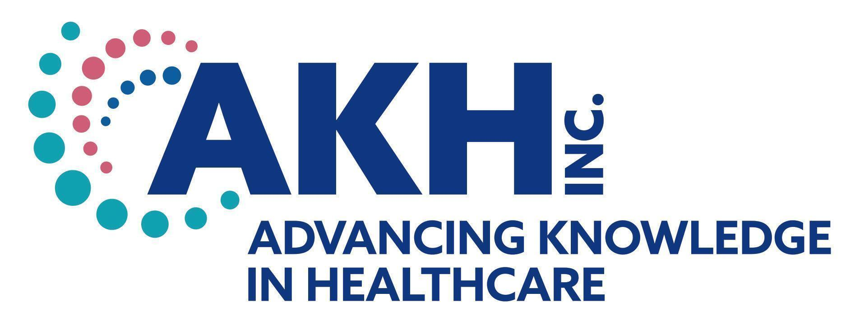
CE credit provided by AKH Inc., Advancing Knowledge in Healthcare.


In support of improving patient care, this activity has been planned and implemented by AKH Inc., Advancing Knowledge in Healthcare and TAG. AKH Inc., Advancing Knowledge in Healthcare is jointly accredited by the Accreditation Council for Continuing Medical Education (ACCME), the Accreditation Council for Pharmacy Education (ACPE), and the American Nurses Credentialing Center (ANCC), to provide continuing education for the healthcare team.

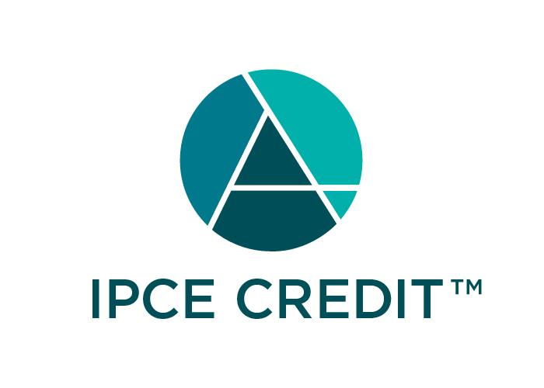This activity was planned by and for the healthcare team, and learners will receive 4.0 Interprofessional Continuing Education (IPCE) credit for learning and change.

Physicians
AKH Inc., Advancing Knowledge in Healthcare designates this live activity for a maximum of 4.0 AMA PRA Category 1 Credit(s)™. Physicians should claim only the credit commensurate with the extent of their participation in the activity.

Nurses
Credit being awarded: 4.0 ANCC contact hours

Commercial Support
There is no commercial support for this activity.

DISCLOSURES
Name | Relationship | Commercial Interest
Sebastian Cotofana, MD, PHD, PHD (faculty)
Dorothy Caputo, MA, BSN, RN - President, AKH Inc., Advancing Knowledge in Healthcare | N/A | Nothing to disclose
Rebecca Lakofsky, BSN, RN (planner/reviewer) | N/A | Nothing to disclose
AKH Inc Staff and Planners | N/A | Nothing to disclose
TAG Staff and Planners | N/A | Nothing to disclose
All of the relevant financial relationships listed for these individuals have been mitigated.

Disclosures
It is the policy of AKH Inc. to ensure independence, balance, objectivity, scientific rigor, and integrity in all of its continuing education activities. The author must disclose to the participants any significant relationships with ineligible companies whose products or devices may be mentioned in the activity or with the commercial supporter of this continuing education activity. Identified conflicts of interest are mitigated by AKH prior to accreditation of the activity. AKH planners and reviewers have no relevant financial relationships to disclose.

Disclosure of Unlabeled Use and Investigational Product
This educational activity may include discussion of uses of agents that are investigational and/or unapproved by the FDA. Please refer to the official prescribing information for each product for discussion of approved indications, contraindications, and warnings.

Disclaimer
This course is designed solely to provide the healthcare professional with information to assist in his/her practice and professional development and is not to be considered a diagnostic tool to replace professional advice or treatment. The course serves as a general guide to the healthcare professional, and therefore, cannot be considered as giving legal, nursing, medical, or other professional advice in specific cases. AKH Inc. specifically disclaim responsibility for any adverse consequences resulting directly or indirectly from information in the course, for undetected error, or through participants misunderstanding of the content. If you would like to opt out from future communications from AKH please send an email to optout@akhcme.com with your information with "Opt Out" in the subject line.

